**PRE-LAB REPORT**

**Experiment No :** 03

**Name of The Experiment :** Study of Diode Full-Wave Rectifier Circuit.

**Circuit Diagram :**

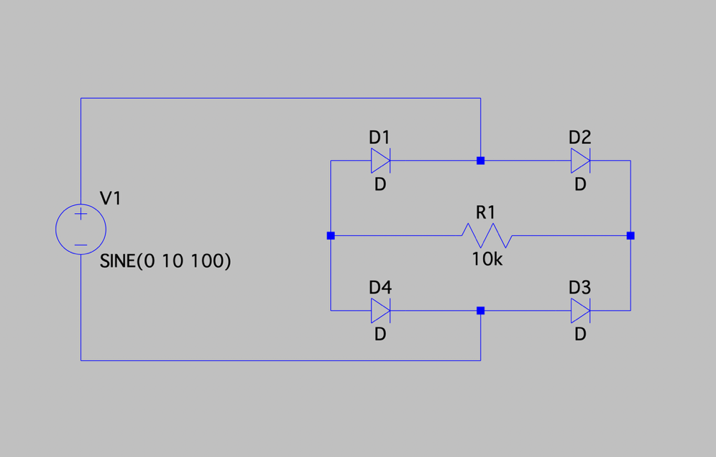

**Input :**

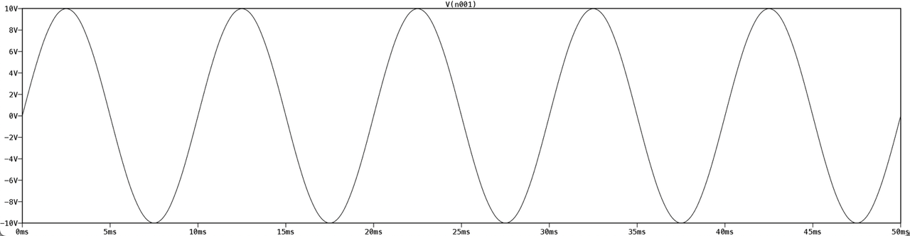

**Output :**

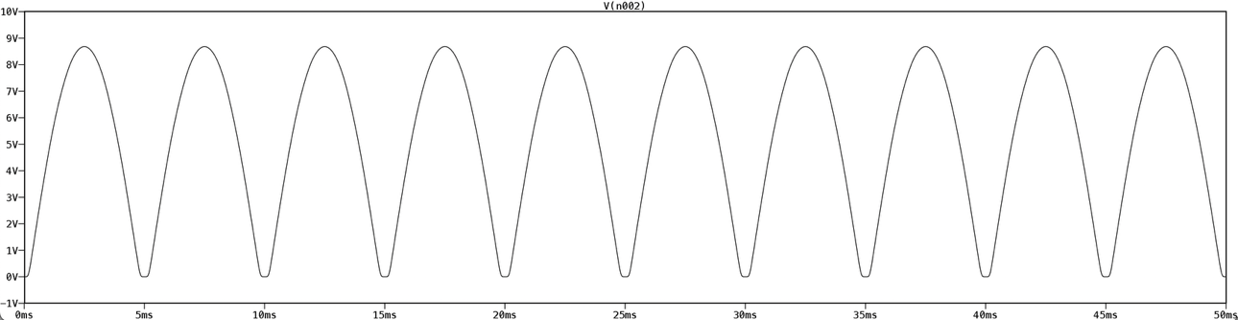

**Summary :**

Here the input voltage is a sine wave with an amplitude of 10V and frequency of 100Hz. The resistance of the resistor is 10kΩ.